For the small jar:
Lids: Vinyl - Clear Inside Application 50 x 50mm * 80 pieces
All lids should have this circle sticker regardless of flavour.
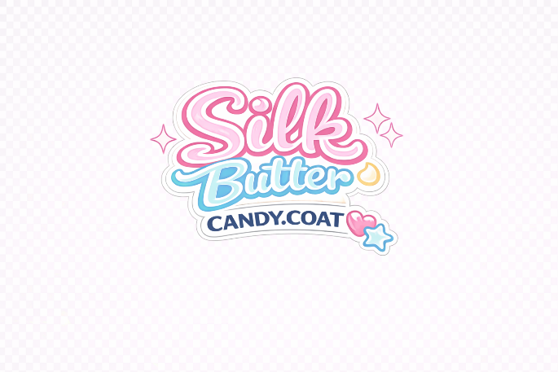
Below is for the stickers that wrap around the Jars. We have four flavours for now and they are listed below:
- Cotton Candy Swirl Vinyl – (Clear Inside Application 225 x 35mm Small Jar only * 40 Pieces)
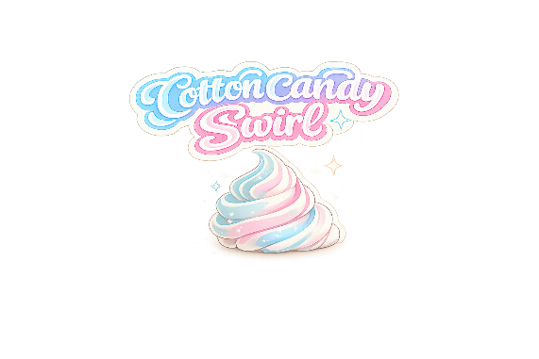
That is the label for Cotton Candy Swirl. I would like the below information added:
A rich, fluffy, vegan and organic body butter that deeply moisturizes and leaves skin soft, smooth, and glowing.”
“Shea Butter + Mango Butter + Jojoba Oil + Grape Seed Oil + Vitamin E”
“24 hours of nourishing moisture”
♡ ♡ Tightens and tones
♡ Anti-inflammatory
♡ Scar & stretch mark care
♡ Alleviates eczema
♡ Helps with acne
♡ Glowing, healthy skin
How to Use: Apply to clean skin and massage until absorbed.
- Caution: For external use only. Avoid eyes. Discontinue if irritation occurs.
- Storage: Store in a cool, dry place. May soften in warm temperatures.

- Buttercream Bliss (Clear Inside Application 225 x 35mm Small Jar only * 40 Pieces)

A rich, fluffy organic body butter that deeply moisturizes and leaves skin soft, smooth, and glowing.”
“Shea Butter + Coconut Oil + Jojoba Oil + Vitamin E”
“24 hours of nourishing moisture”
♡ Tightens and tones
♡ Anti-inflammatory
♡ Scar & stretch mark care
♡ Alleviates eczema
♡ Helps with acne
♡ Glowing, healthy skin
- How to Use: Apply to clean skin and massage until absorbed.
- Caution: For external use only. Avoid eyes. Discontinue if irritation occurs.
- Storage: Store in a cool, dry place. May soften in warm temperatures.

- Citrus Kiss (Clear Inside Application 225 x 35mm Small Jar only * 20 Pieces)
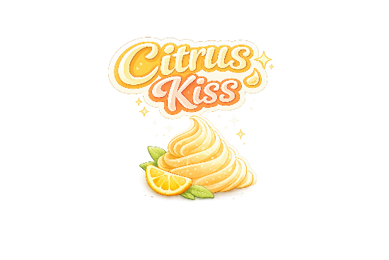
A rich, fluffy organic body butter that deeply moisturizes and leaves skin soft, smooth, and glowing.”
“Shea Butter + Mango Butter + Sweet Almond Oil + Jojoba Oil + Vitamin E”
“24 hours of nourishing moisture”
♡ Tightens and tones
♡ Anti-inflammatory
♡ Scar & stretch mark care
♡ Alleviates eczema
♡ Helps with acne
♡ Glowing, healthy skin
- How to Use: Apply to clean skin and massage until absorbed.
- Caution: For external use only. Avoid eyes. Discontinue if irritation occurs.
- Storage: Store in a cool, dry place. May soften in warm temperatures.

- Powder Cloud (Clear Inside Application 225 x 35mm Small Jar only * 40 Pieces)
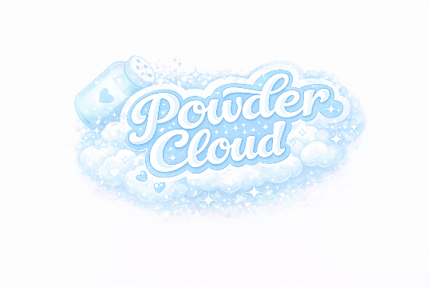
A rich, fluffy, vegan and organic body butter that deeply moisturizes and leaves skin soft, smooth, and glowing.”
“Shea Butter + Jojoba + Coconut+ Vitamin E”
“24 hours of nourishing moisture”
♡ Tightens and tones
♡ Anti-inflammatory
♡ Scar & stretch mark care
♡ Alleviates eczema
♡ Helps with acne
♡ Glowing, healthy skin
- How to Use: Apply to clean skin and massage until absorbed.
- Caution: For external use only. Avoid eyes. Discontinue if irritation occurs.
- Storage: Store in a cool, dry place. May soften in warm temperatures.
Melon Mousse
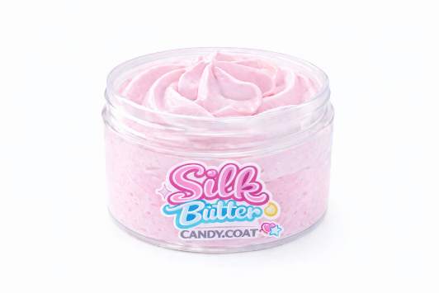
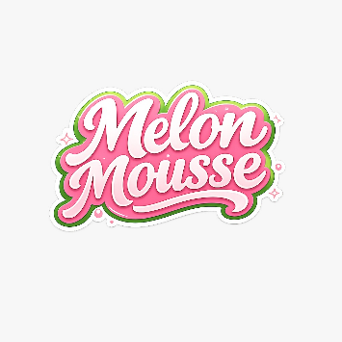
Ingredients
“Shea Butter + Mango Butter + Sweet Almond+ Vitamin E”
“24 hours of nourishing moisture”
♡ Tightens and tones
♡ Anti-inflammatory
♡ Scar & stretch mark care
♡ Alleviates eczema
♡ Helps with acne
♡ Glowing, healthy skin

My EASIEST Whipped Shea Butter Yet! (3 WAYS)
